**Assigning Instructor to Non-Existent Course (bug)**

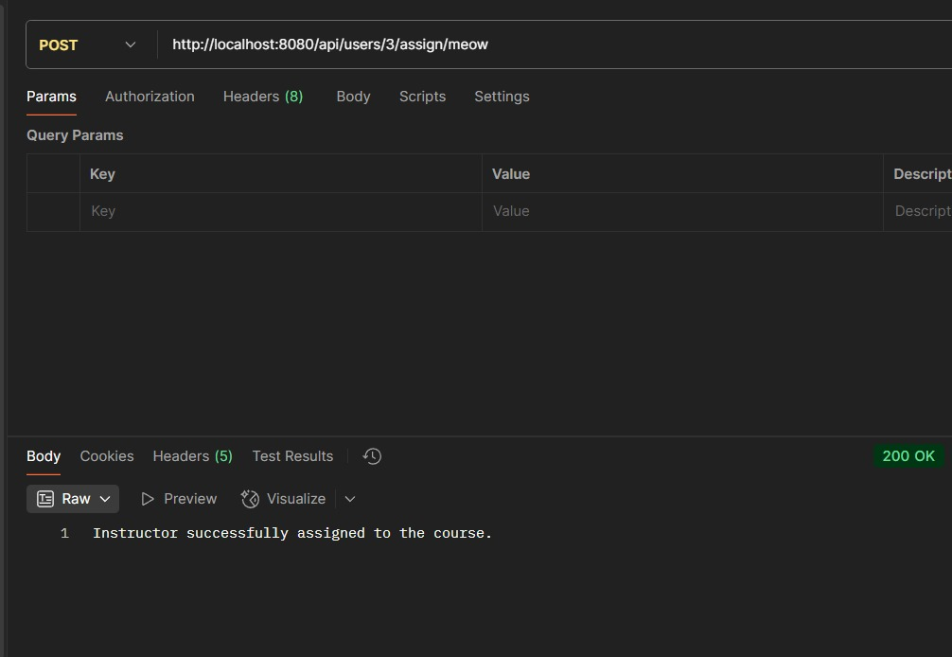Before

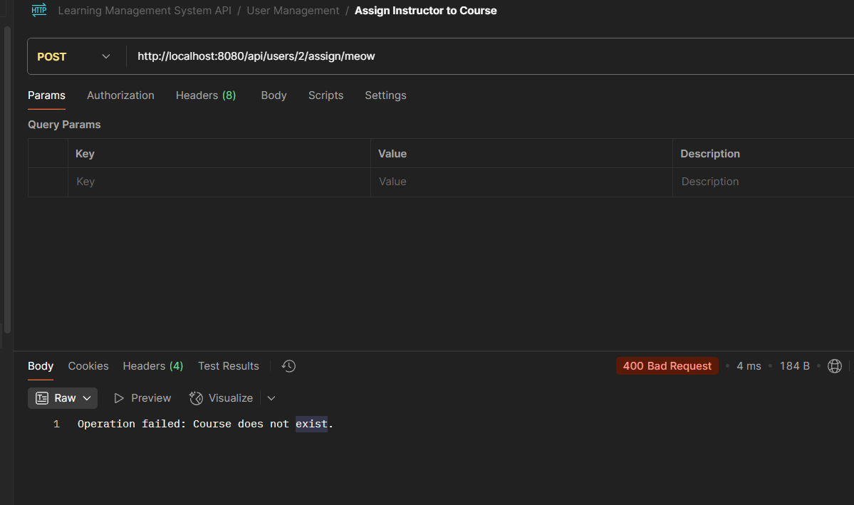After

**PUT Request Nullifies Unspecified Sections (bug)**

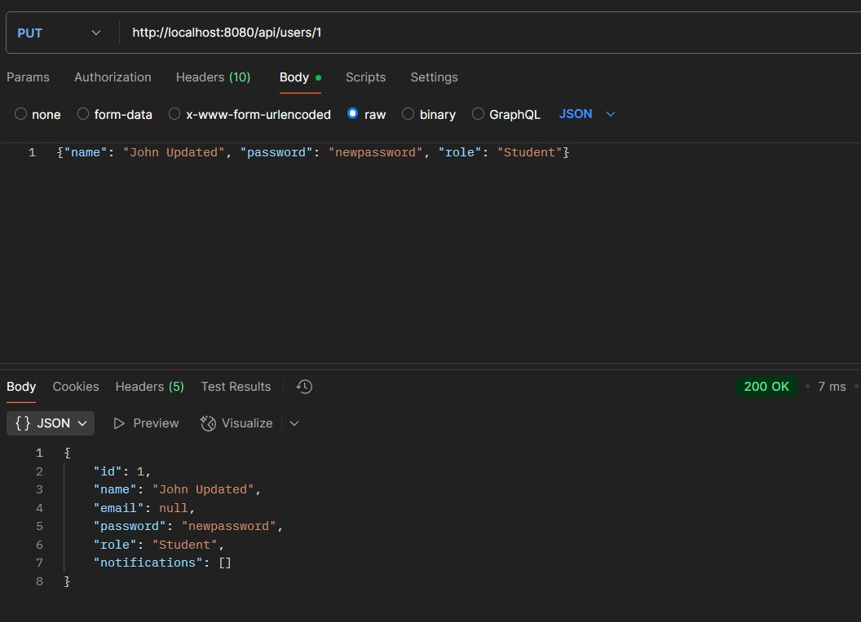Before

After

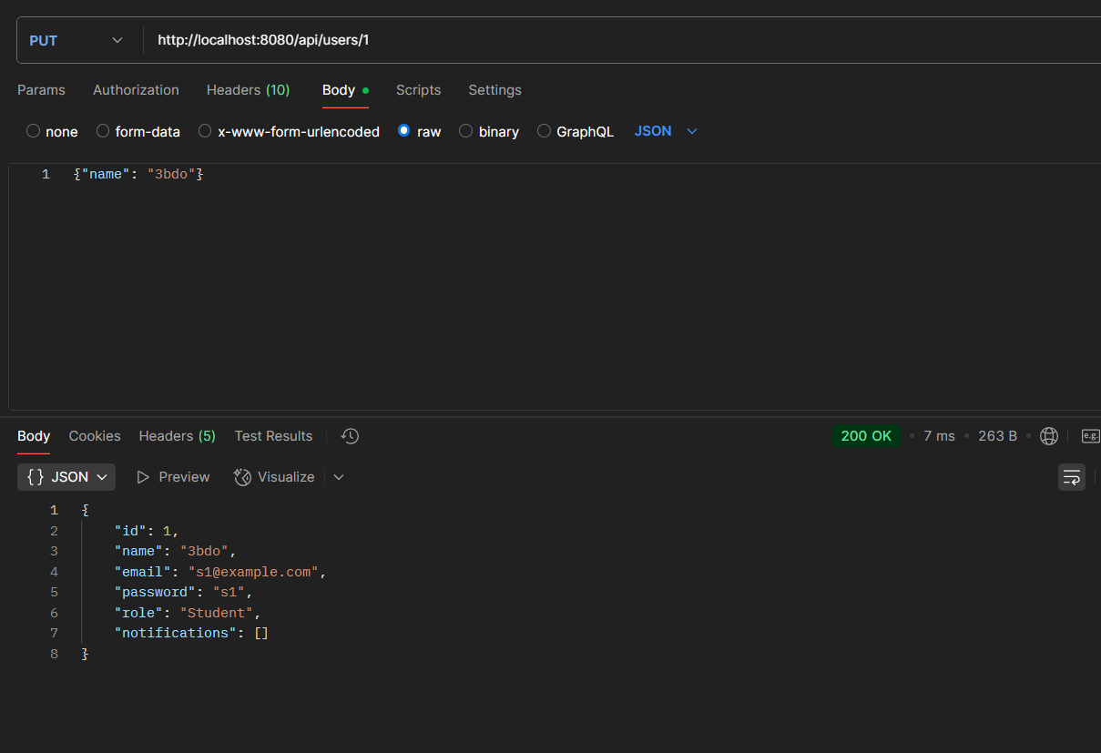

**Enrollment Success into Non-Existent Course (bug)**

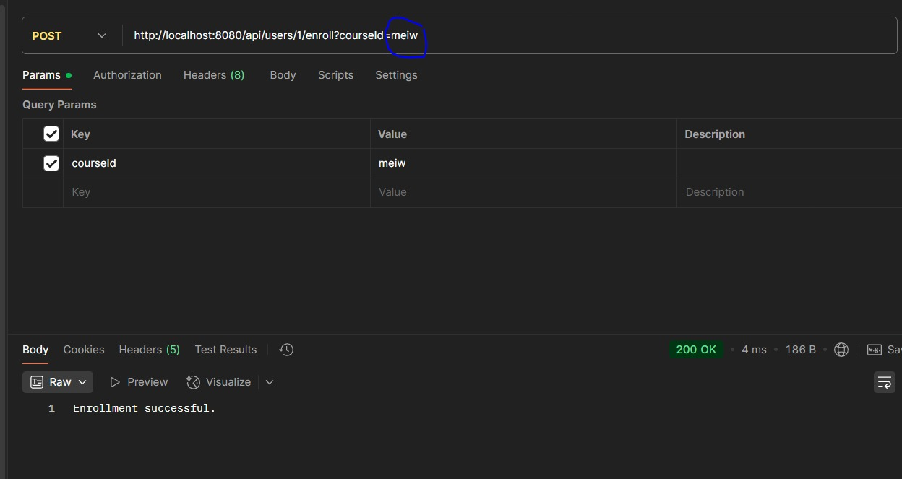Before

After

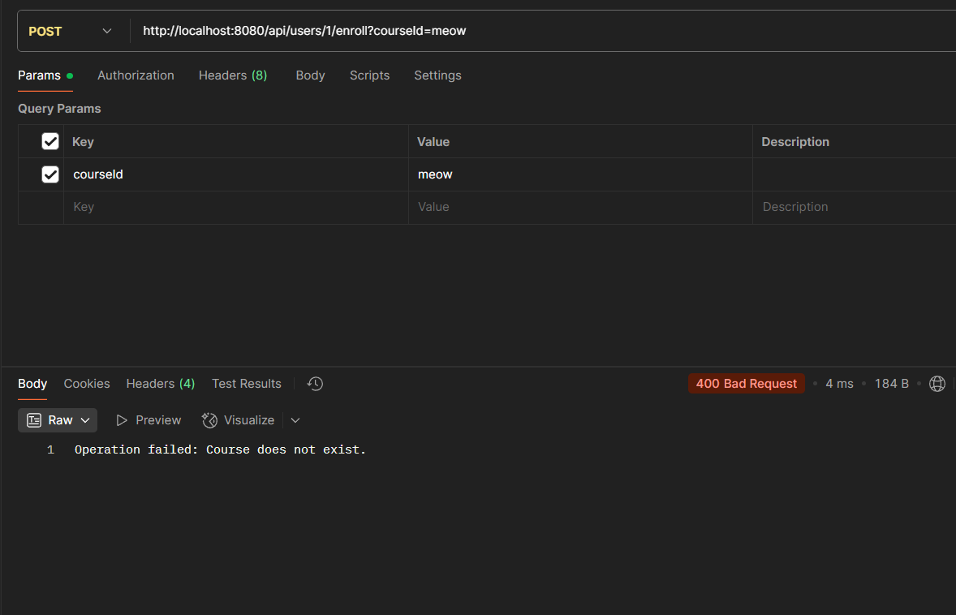

**Assigning Instructor to Non-Existent Course (bug):**

When the user tries to assign an instructor to a course that doesn’t exist he gets a message that the instructor got assigned successfully, but now if the same happens the user will get a message “operation failed, saying course does not exist”

**PUT Request Nullifies Unspecified Sections (bug)**

When a user tries to update some of his information, the ones that are not selected will be updated to NULL. Now if a user applies changes to any piece of information the not modified ones will remain the same instead of becoming NULL

**Enrollment Success into Non-Existent Course (bug)**

When a student tries to enroll into a non-existent course he will get a message saying he enrolled successfully, now if it happens the student will get a message saying “operation failed, course does not exist”.